**Supplementary Material**

**Source- and polymer-specific size distributions of fine microplastics in surface water in an urban river**

Yutaka Kameda†*, Naofumi Yamada†, Emiko Fujita†

† Chiba Institute of Technology, 1-17-1 Tsudanuma, Narashino, Chiba 275-0016 Japan

* Corresponding author

phone: +81 474 78 4756; fax: +81 474 78 4756; email: yutaka.kameda@it-chiba.ac.jp

Number of pages: 26

Number of Figures: 9

Number of Tables: 5

**Contents:**

A developed sampling system for microplastics in surface water and pictures of the sampling sites. (Figure S1) **S3**

The sampling method to collect microplastics in surface water. (Figure S2) **S4**

Pretreatment process of microplastics in surface water. (Figure S3) **S5**

A purpose-designed plate for PTFE membranes for Micro-FTIR analysis.

(Figure S4)  **S7**

Three Micro-FTIR scan areas on the membrane (Figure S5) **S8**

Concentrations of fibrous MPs detected in surface water samples. (Figure S6) **S9**

Concentrations of fibrous MPs detected in influent and effluent sample.

(Figure S7) **S10**

A plot of scale parameters relation to size parameters of Weibull cumulative

distribution functions of MPs polymers in surface water, influent and effluent

samples (Figure S8) **S11**

Scale parameters of Weibull cumulative distribution functions for 5 dominant polymers in surface water (Figure S9) **S12**

Water quality, flow rates of all sampling sites in the Tsurumi River as well as populations, areas and land use types in their catchments. (Table S1) **S13**

Eighteen polymer types measured in this study and their tensile strength.

(Table S2) **S14**

The concentrations and profiles of MPs in surface water, influent and effluent.

(Table S3) **S15**

Minimum and maximum of average sizes of observed microplastics, estimated 10th, 50th and 90th particle sizes from Weibull models and parameters used for the models for all MPs and each polymer type in surface water (Table S4) **S16**

Major size, minor size and plastics polymer types of all MPs detected in surface water (Table S5) **S17**





**Site A Site B**



 **Site C Site D**

**Site E**

**Figure S1. A developed sampling system for microplastics in surface water and pictures of the sampling sites**



**Figure S2. The sampling method to collect microplastics in surface water**

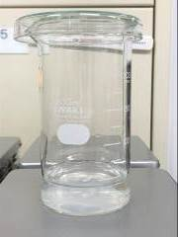STEP 1

The membranes were pooled in a tall form 200 mL beaker directly and 40 mL of 30% hydrogen peroxide was added slowly for the digestion.

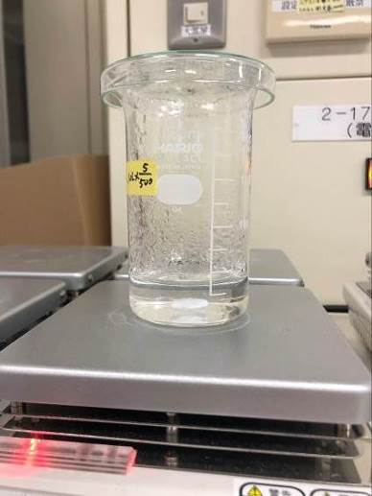

STEP 2

The digestion was conducted at 60°C for a few days (2-3 days) under stirring at a speed of 100 rpm with a glass lid.

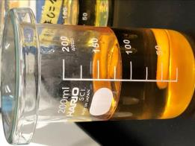STEP 3

After the confirmation of sufficient digestion, ultra-purified water was added up to 100 mL and finally 100 g of sodium iodide was added in the beaker for density separation.

STEP 4

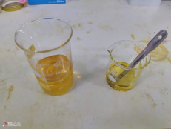

Pooled supernatant

(Microplastics)

Sample in NaI solution

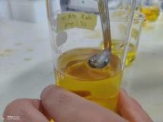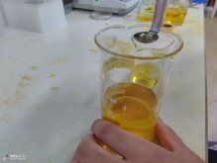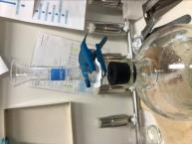

After stirring for 10 min, the solution was stored statically for more than 6 h. After the density separation procedure, the 20 mL of supernatant was collected by a small ladle from the beaker to another beaker manually. The stirring and supernatant collection procedure was repeated three times and the supernatants were pooled in the beaker.

Collect surface portion of supernatant carefully.

STEP 5

Finally, 60 mL of the supernatant was passed through the area with 18 mm ø in a 47 mm ø a hydrophilic PTFE membrane by a thin glass filter holder (ADVANTEC, Tokyo, Japan) in order to accumulate MPs on a small area of the membrane.

**Figure S3. Pretreatment process of microplastics in surface water**

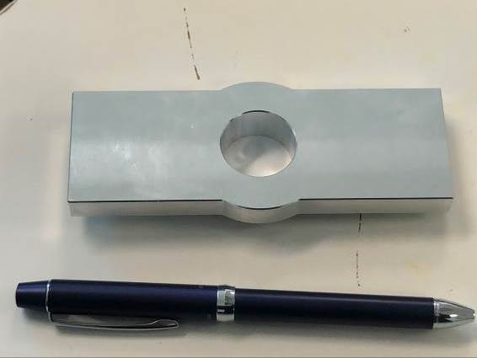

Here is a scan area on a membrane

**Figure S4. A purpose-designed plate for PTFE membranes**

**for Micro-FTIR analysis**



**Figure S5. Three Micro-FTIR scan areas on the membrane**



**Figure S6. Concentrations of fibrous MPs detected in surface water samples.**



**Figure S7. Concentrations of fibrous MPs detected in influent and effluent sample.**



**Figure S8. A plot of scale parameters relation to size parameters of Weibull cumulative distribution functions of MPs polymers in surface water, influent and effluent samples**



**Figure S9. Scale parameters of Weibull cumulative distribution functions for 5 dominant polymers polymers in surface water**

Table S1. Water quality, flow rates of all sampling sites in the Tsurumi River as well as populations, areas and land use types in their catchments. P, A, F, U and O indicate “Paddy fields”, “Agricultural fields”, “Forests”, “Urban areas” and “Others”, respectively.

|  |  |  |  |  |  |  |  |  |  |
| --- | --- | --- | --- | --- | --- | --- | --- | --- | --- |
| Site | Water quality  (BOD: mg/L) | Flowrate  (m3/s) | Population  in the catchment | Catchment Area  (km2) | Land use types in catchments (%) | | | | |
| P | A | F | U | O |
| A | 0.7 | 0.0005 | approx. 50 | 0.558 | 0.1 | 12.4 | 70 | 10.5 | 7.0 |
| B | 4.7 | 0.42 | 53,000 | 27.2 | 2.3 | 7.8 | 31.1 | 49.7 | 9.1 |
| C | 2.0 | 4.01 | 339,000 | 68.5 | 2.3 | 6.6 | 20.5 | 60.2 | 10.6 |
| D | 2.7 | 5.99 | 780,000 | 146.3 | 2.1 | 7.8 | 16.1 | 62.7 | 11.4 |
| E | 1.1 | 9.27 | 1,970,000 | 233.6 | 1.3 | 6.2 | 12 | 68.2 | 12.3 |

Table S2. Eighteen polymer types measured in this study and their tensile strength

|  |  |  |  |
| --- | --- | --- | --- |
| I.D | Polymer name | Abbreviation | Tensile strength of virgin polymer (kg/cm2)※ |
| 1 | Acrylonitrile-butadiene-styrene | ABS | 345 1) |
| 2 | Alkyd resin | Alkyd | 420-910 2) |
| 3 | Styrene-acrylonitrile resin | AS | 670-840 2) |
| 4 | Epoxy resin | Epoxy | 280-910 2) |
| 5 | Polyamide | PA | 490-860 4) |
| 6 | Polyethylene | PE | 70-390 2) |
| 7 | Polyethylene terephthalate | PET | 1200-1760 2) |
| 8 | Polyisoprene | PIP | 50-200 3) |
| 9 | Polymethyl methacrylate | PMMA | 490-770 2) |
| 10 | Polypropylene | PP | 300-390 2) |
| 11 | Polyphenylene sulfide | PPS | 1880 2) |
| 12 | Polystyrene | PS | 350-630 2) |
| 13 | Polyurethane foam | PU | 410 2) |
| 14 | Polyvinyl acetate | PVAc | 98-270 2) |
| 15 | Polyvinyl alcohol | PVAl | 70-350 2) |
| 16 | Polyvinyl chloride | PVC | 105-630 2) |
| 17 | Poly (vinyl methyl ether) | PVME | No data |
| 18 | Styrene-butadiene | SBR | * 1. 3) |

※　Average values of minimum data and maximum data were used in this article.

1)http://www.k-techno.ne.jp/company/physicality_table2.html

2)https://kayo-corp.co.jp/common/pdf/pla_propertylist02.pdf#search=%27%E3%82%A2%E3%83%AB%E3%82%AD%E3%83%89%E3%83%AC%E3%82%B8%E3%83%B3+%E5%BC%95%E5%BC%B5%E5%BC%B7%E5%BA%A6%27

3)https://kayo-corp.co.jp/common/pdf/rub_propertylist.pdf

4)https://kayo-corp.co.jp/common/pdf/pla_propertylist01.pdf#search=%27%E3%83%9D%E3%83%AA%E3%82%A2%E3%83%9F%E3%83%89+%E5%BC%95%E5%BC%B5%E5%BC%B7%E5%BA%A6%27

Table S3. The concentrations and profiles of MPs in surface water, influent and effluent.

|  |  |  |  |  |  |  |  |
| --- | --- | --- | --- | --- | --- | --- | --- |
| Concentration (average±standard deviation, particles/m3) * The unit of influent sample is “×103particles/ m3”. | | | | | | | |
|  | Site A | Site B | Site C | Site D | Site E | Influent* | Effluent |
| ABS | 0 | 13.6±4.8 | 0 | 10.2±14.4 | 17.0±17.3 | 0 | 33.9±19.6 |
| Alkyd | 30.5±21.6 | 183±144 | 44.1±9.6 | 353±47.2 | 288±168 | 84.8±20.7 | 305±102 |
| AS | 7.6±4.4 | 6.8±4.8 | 3.4±4.8 | 3.4±4.8 | 3.4±4.8 | 17.0±9.8 | 67.8±19.6 |
| Epoxy | 15.3±15.3 | 23.7±33.6 | 0 | 3.4±4.8 | 17.0±9.6 | 33.9±5.2 | 0 |
| PA | 22.9±18.1 | 6.8±4.8 | 0 | 3.4±4.8 | 6.8±4.8 | 0 | 33.9±19.6 |
| PE | 168±19.2 | 84.8±48.7 | 50.9±22.0 | 159±41.0 | 217±67.1 | 122±10.2 | 170±70.6 |
| PET | 17.8±20.8 | 23.7±26.7 | 0 | 37.3±12.7 | 94.9±63.4 | 203±48.9 | 407±122 |
| PIP | 0 | 0 | 0 | 0 | 0 | 0 | 0 |
| PMMA | 38.2±29.1 | 50.9±50.5 | 3.4±4.8 | 57.6±26.7 | 37.3±33.6 | 44.1±7.8 | 305±117 |
| PP | 25.4±32.6 | 146±95.6 | 180±87.3 | 173±61.2 | 458±24.9 | 502±168 | 848±171 |
| PPS | 0 | 0 | 0 | 0 | 0 | 0 | 0 |
| PS | 2.5±4.4 | 3.4±4.8 | 3.4±4.8 | 3.4±4.8 | 20.3±8.3 | 3.4±2.0 | 33.9±19.6 |
| PU | 0 | 13.6±4.8 | 3.4±4.8 | 23.7±9.6 | 10.2±8.3 | 13.6±5.2 | 136±51.8 |
| PVAc | 0 | 13.6±4.8 | 6.8±9.6 | 20.3±14.4 | 27.1±25.4 | 0 | 0 |
| PVAl | 0 | 0 | 0 | 0 | 0 | 0 | 0 |
| PVC | 2.5±4.4 | 3.4±4.8 | 10.2±14.4 | 30.5±22.0 | 10.2±8.3 | 3.4±2.0 | 33.9±19.6 |
| PVME | 0 | 0 | 0 | 0 | 0 | 0 | 0 |
| SBR | 0 | 3.4±4.8 | 6.8±9.6 | 6.8±4.8 | 20.3±28.8 | 0 | 0 |
| Total | 300±235 | 587±409 | 298±105 | 888±58.3 | 1240±295 | 1030±212 | 2370±513 |

Table S4. Minimum and maximum of average sizes of observed microplastics, estimated 10th, 50th and 90th particle sizes from Weibull models and parameters used for the models for all MPs and each polymer type in surface water



Table S5. Major size, minor size and plastics polymer types of all MPs detected in surface water

＜Site A＞



＜Site B＞





＜Site C＞



＜Site D＞





＜Site E＞





＜Influent＞

※　The sizes of microplastics in the influent sample were analyzed in only one scan area. The concentrations of polymers were measured in three scan areas.

＜Effluent＞